Name___________________________________________ Block/Period________  
MISA- Relationship of Plate Boundaries, Earthquakes, and Volcanoes

**How Plate Tectonics Works**

1. Earth’s crust and the top part of the mantle — the next layer in toward the core of our planet — run about 62 miles (100 km) deep. Together, they are called the lithosphere, and make up the “plates” in plate tectonics. We now know there are 15 major plates that cover the planet’s surface, moving at around at about the speed at which our fingernails grow.
2. Based on the dating of rocks, we know that no ocean is more than 200 million years old, though our continents are much older. The oceans’ opening and closing process, called the Wilson cycle, explains how the Earth’s surface evolves.
3. A continent breaks up when hot molten rock inside Earth changes its flow. That, in turn, affects the lithosphere, changing the direction plates move. This is how, for instance, South America broke away from Africa.
4. Then, the continent drifted away, the sea floor spread out, and the Atlantic Ocean was formed. In fact, the Atlantic is still opening, generating new plate material in the middle of the ocean. This makes the distance between New York and London a few inches longer each year.
5. Oceans close when their tectonic plate sinks beneath another, a process geologists call subduction. Off the Pacific Northwest coast of the United States, the ocean is slipping under the continent and into the mantle below the lithosphere. In slow motion, it is creating Mount St. Helens and the Cascade mountain range.

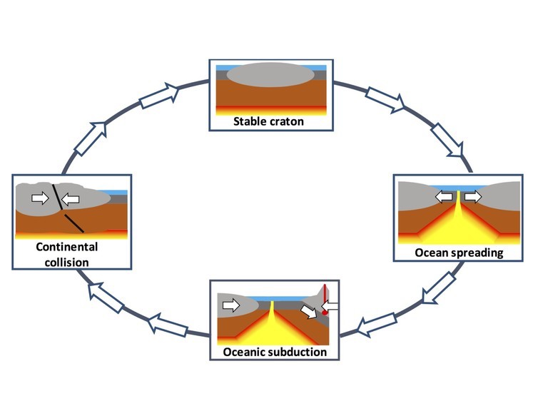A simplified "Wilson Cycle" (left)

1. In addition to undergoing spreading (construction) and subduction (destruction), plates can simply rub up against each other, usually generating large earthquakes. All three processes occur at the edges of plate boundaries.

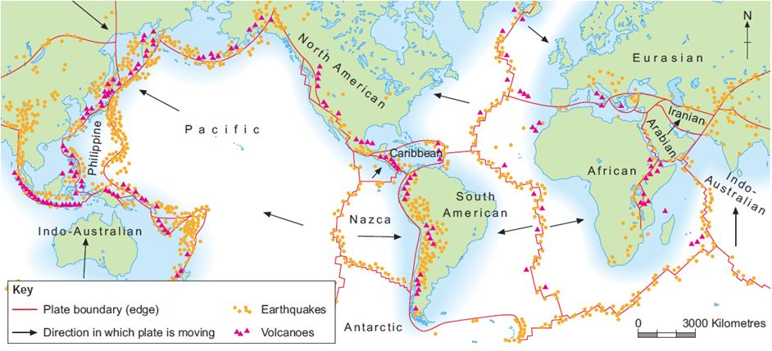

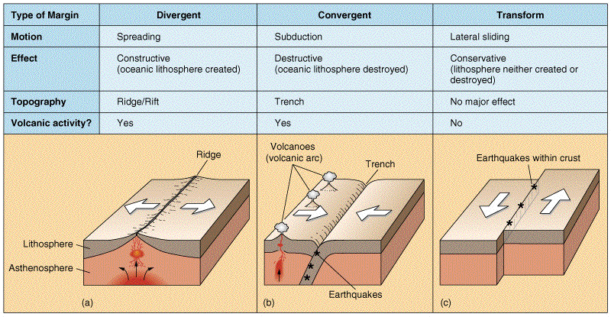

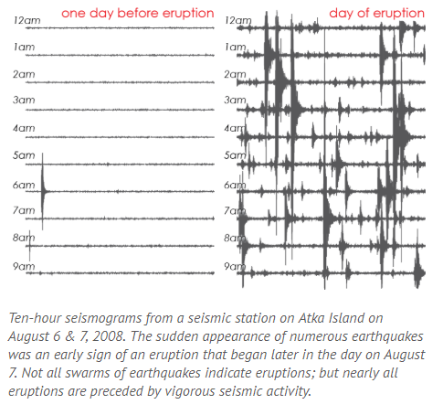**EARTHQUAKES NEAR VOLCANOES**

1. 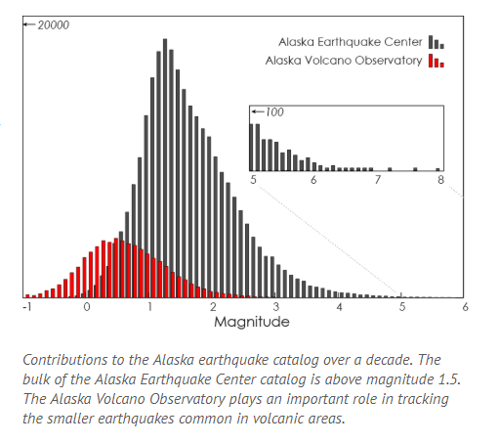The earthquakes that occur near volcanoes are usually not damaging and are typically not even felt. They can, however, occur in very large numbers. Their occurrence can indicate changes in or near the volcano. These changes may be due to the movement of magma or gas, may result from moving ice or debris, or may simply reflect the adjustment of stresses in the surrounding region. Each of these sources produces seismograms with unique signatures that can often be used to assess the cause of the earthquake. At times, the presence of certain types of earthquakes or numerous earthquakes, accompanied by other indicators, can be indicative of forthcoming eruptions.  
     
   8. Subduction zones, where most active volcanoes are found, also generate high rates of earthquakes that are not volcanic. Though volcanic activity causes only a small proportion of Alaska's earthquakes, these earthquakes often warrant more detailed analysis.

Part 1:

1. What is the correlation of volcano and earthquake global locations? Use evidence to support your answer.

_____________________________________________________________________________________________________________________________________________________________________________________________________________________________________________________________________

1. By looking at the Alaska Earthquake and Volcano data and paragraph 7, describe the relationship between Alaska Earthquakes and Volcanic eruptions.

____________________________________________________________________________________________________________________________________________________________________________________________________________________________________________________________________________________________________________________________________________________________

1. Using evidence from paragraphs 4 and 5 describe why the Earth is not growing.

____________________________________________________________________________________________________________________________________________________________________________________________________________________________________________________________________________________________________________________________________________________________

1. Describe the relationship between each boundary and the type of earthquake and volcanic activity found there. Use specific examples from the diagrams.

____________________________________________________________________________________________________________________________________________________________________________________________________________________________________________________________________________________________________________________________________________________________

Part 2: Writing Prompt

Explain the relationship between the location of Plate Boundaries, Earthquakes, and Volcanoes. Use evidence to support the answer. Write (two) well written paragraphs, including an introduction, body, and conclusion. Use proper spelling, grammar, capitalization, and punctuation.

**_______________________________________________________________________________________________________________________________________________________________________________________________________________________________________________________________________________________________________________________________________________________________________________________________________________________________________________________________________________________________________________________________________________________________________________________________________________________________________________________________________________________________________________________________________________________________________________________________________________________________________________________________________________________________________________________________________________________________________________________________________________________________________________________________________________________________________________________________________________________________________________________________________________________________________________________________________________________________________________________________________________________________________________________________________________________________________________________________________________________________________________________________________________________________________________________________________________________________________________________________________________________________________________________________________________________________________________________________________________________________________________________________________________________________________________________________________________________________________________________________________________________________________**